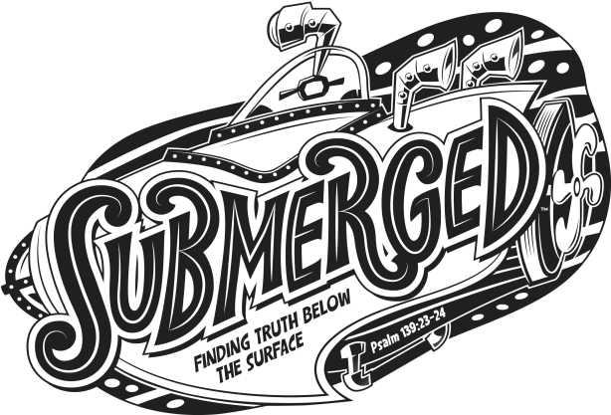
New Orleans Chinese Baptist Church
Vacation Bible School
May 30th to June 3rd, 2016
Registration Deadline: May 22nd (Sunday)

Where: New Orleans Chinese Baptist Church, 3413 Continental Dr., Kenner, LA 70065
When: May 30th – June 3rd (daily from 9 a.m. to 5 p.m.) June 3rd (7:00 pm, VBS Closing Ceremony)
Who: 4 to 12 years old kids; youth 13 or older can volunteer
Frequently Asked Questions for Children and Parents:
Q: What is vacation bible school (VBS)?
A: VBS is not a school. There is no homework and no test. At VBS, there will be bible stories, songs, crafts, games, water slides, friends, and a ton of laughs. VBS is really a fun way to learn more about God.
Q: I'm not a Christian and I don't speak Chinese. Can I go to VBS?
A: Sure! As long as you are between 4 and 12.

Q: Do I need to bring anything to VBS?
A: Nope! The church will provide all the supplies that you need, even lunch and TREATS!!!

______________________________________________________________________________________________________________________________________

VBS Registration Form

Parent’s Name: ______________________________ Email: _________________________________

Home Phone: ______________________________ Cell Phone: _____________________________

Child’s Name(s) | Grade just completed | Date of Birth | Special conditions
To volunteer, fill out the following:

Youth’s Name: _________________________________ Grade just completed: _________________

Youth’s Contact info (email and/or cell phone): ______________________________________________

To Register: Mail registration form to church or email form to NOCBC.Youth@gmail.com by May 22.
For more information: Visit www.nocbc.org. E-mail NOCBC.Youth@gmail.com for questions.

